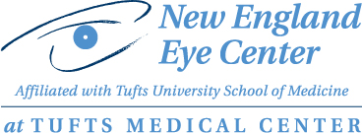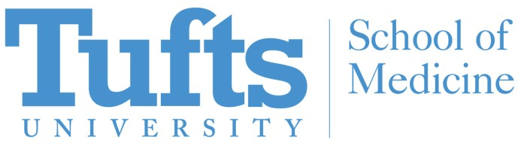

Frontiers in Vision Science 2019

New England Eye Center

W. Daniel Stamer, PhD, FARVO

Joseph A.C. Wadsworth Professor of Ophthalmology
Professor of Biomedical Engineering
Duke University
Durham, NC

Finally targeting disease: The next generation of glaucoma therapeutics

Tuesday, April 2, 2019
Reception: 5:00 PM; Lecture: 5:30 PM

Biewend Auditorium
10th Floor Biewend Building
260 Tremont Street Boston, MA 02116

Parking is available in the Tufts Medical Center Garage at 274 Tremont Street
___________________________

Please RSVP to Rosaline Bowen: rosaline.bowen@tufts.edu

